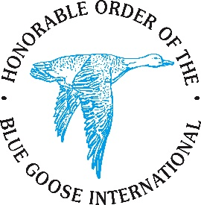
GATEWAY TO THE SOUTH in 2026 Sponsorship Form
Southern Region Run for the Roses Convention Fund

Sponsor Information (please print or type)

Company Name: ____________________________________________________________
Contact Name: ____________________________________________________________
Address: ____________________________________________________________
City, State, Zip Code: ____________________________________________________________
Phone – Office: ____________________________________________________________
Phone – Mobile: ____________________________________________________________
Contact Email: ____________________________________________________________

Pledge Information
Sponsorship Level

Winner’s Circle ($10,000) Derby/Rose ($5,000) Trifecta ($3,000)
Exacta ($2,000) Oaks/Lily ($1,000) Win, Place, Show ($500)
Starting Gate ($250)

Payment can be in the form of a check made out to “The Southern Region Convention Fund” and mailed to Tom Elder, 2010 Montfort Circle, Crestwood, Kentucky 40014.
OR
Contact either Linda Meik (linda,meik9@gmail.com/682-715-5341) to pay by credit card; or Tom Elder (elder @twc.com/502-931-6431).
Blue Goose FEIN is 46-5241020 for your tax purposes.
Please provide a digital copy of your company logo (jpeg or pdf) via email to elder@twc.com for use in our acknowledgements.

